How to set up LDAP
- Download OpenDS from http://www.opends.org/.
- Install and configure OpenDS as in the following figures:
  - Click “Next”
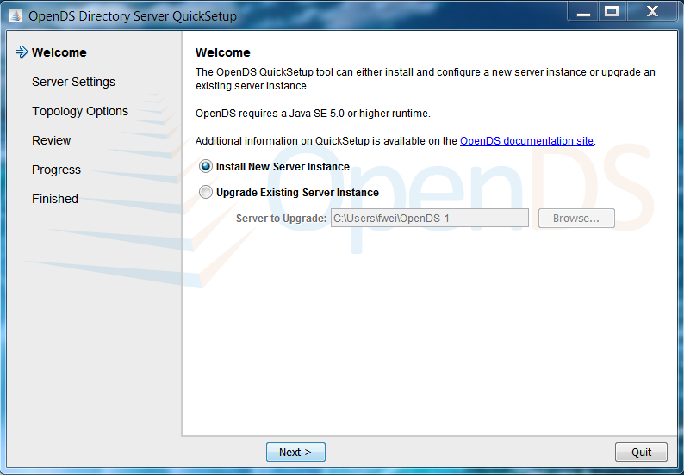

  - Type in “cn=admin,dc=iringug,dc=org” after “Root User DN:” and enter a password, e.g., “admin” and confirm it. Then click “Next”
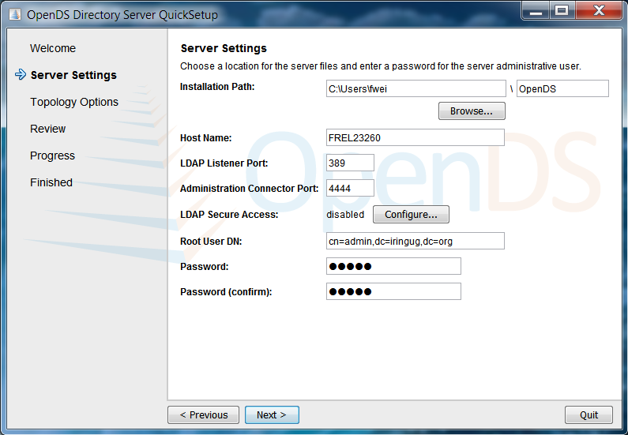

  - Click “Next” without changing anything
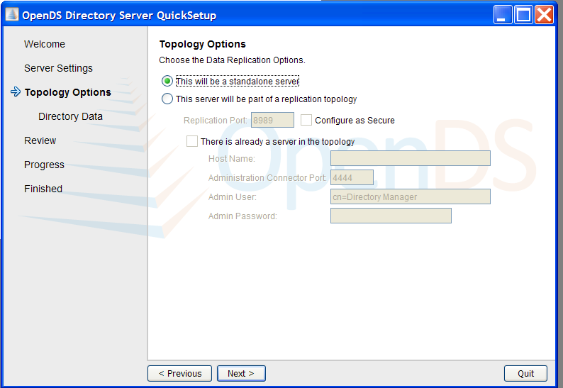

  - Type in “dc=iringug,dc=org” in the field of “Directory Base DN” then click “Next”.
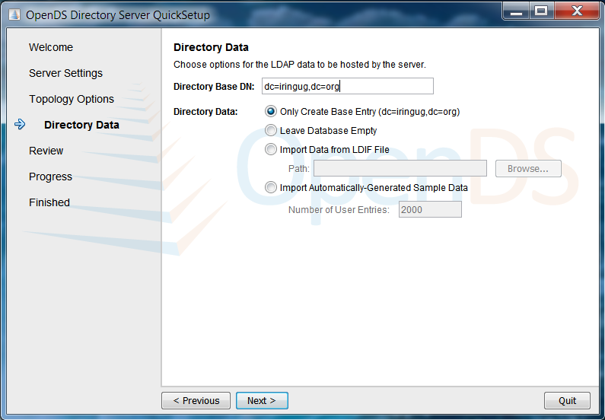

  - Click “Finish”.
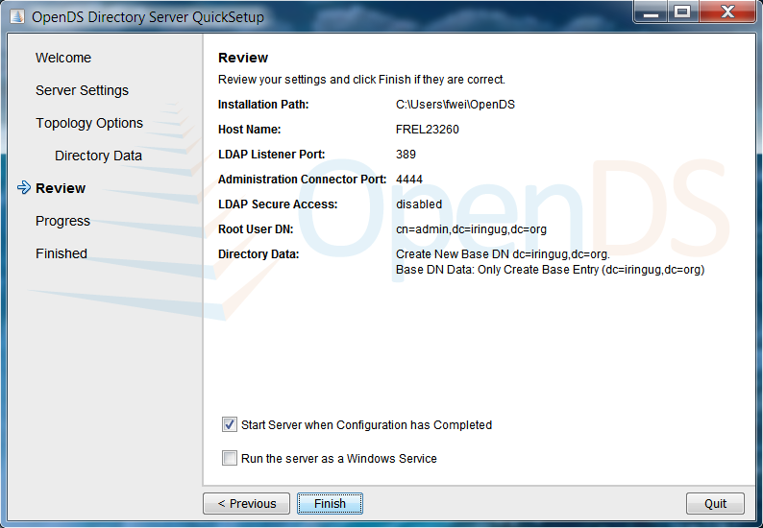
- Paste the file “99-user.ldif” from a directory, e.g., C:\iring-tools\trunk\LDAP to the LDAP schema directory , e.g., C:\Users\xxxxx\OpenDS\config\schema\
- Start OpenDS by running the file “control-panel.bat” in the LDAP directory, e.g., C:\Users\xxxxx\OpenDS\bat\control-panel.bat.
- Click “Restart” to restart the LDAP server.
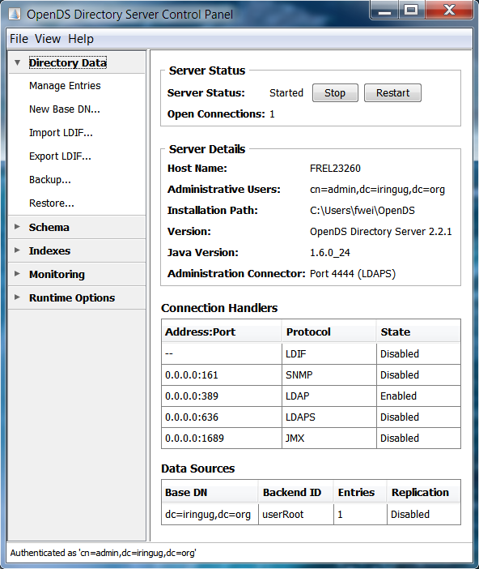
- Download Apache Directory Studio from http://directory.apache.org/studio/ and install it to the computer.
- Open Apache Directory Studio and then right click the white area in the window of “Connections” and click “New Connection…”
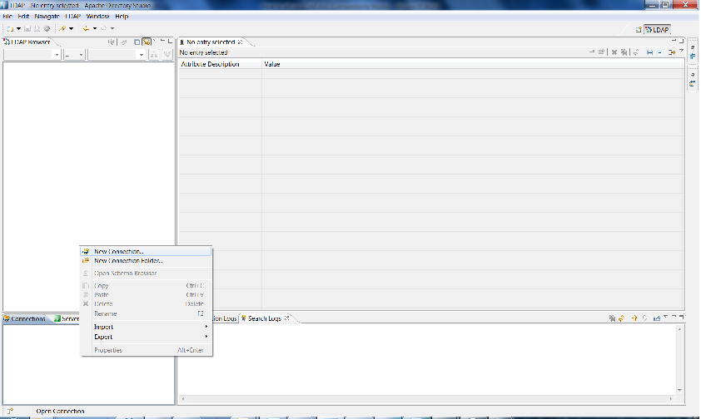
- Enter a name for “Connection name” and type in “localhost” after “Hostname:”. Then click “Next”.
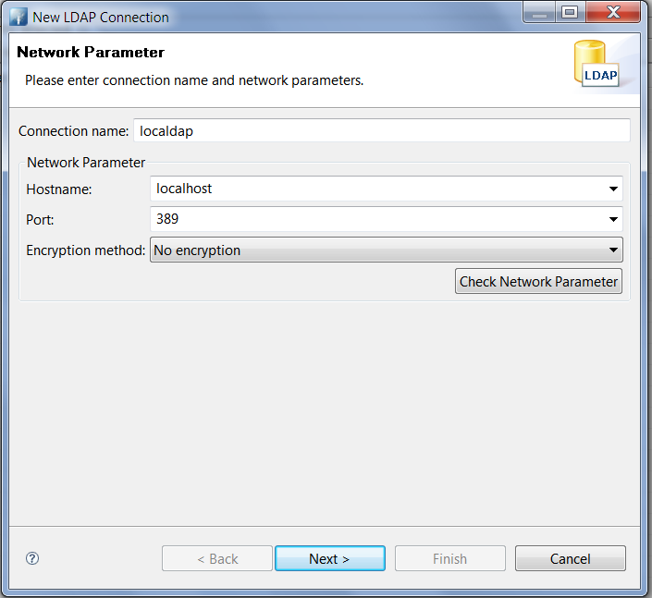

- Type in “cn=admin,dc=iringug,dc=org” after “Bind DN or user:” and the password after “Bind password”. Then click “Next”.
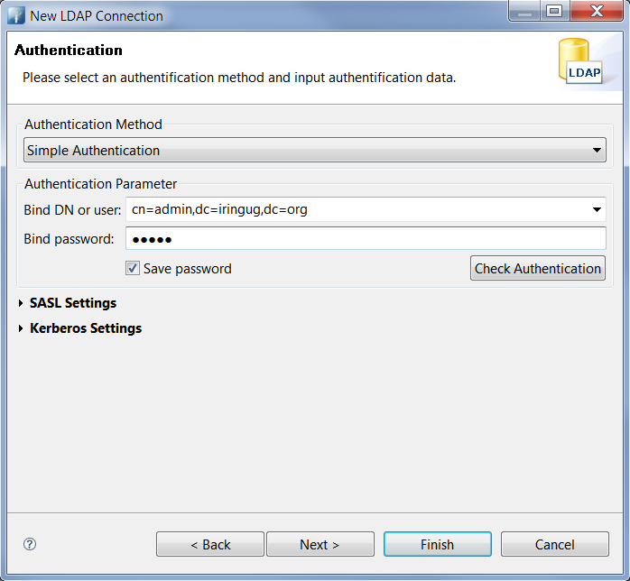
- click “Next” and “Finish” for the next two steps and then the directory shows one entry “dc=iringug,dc=org”.
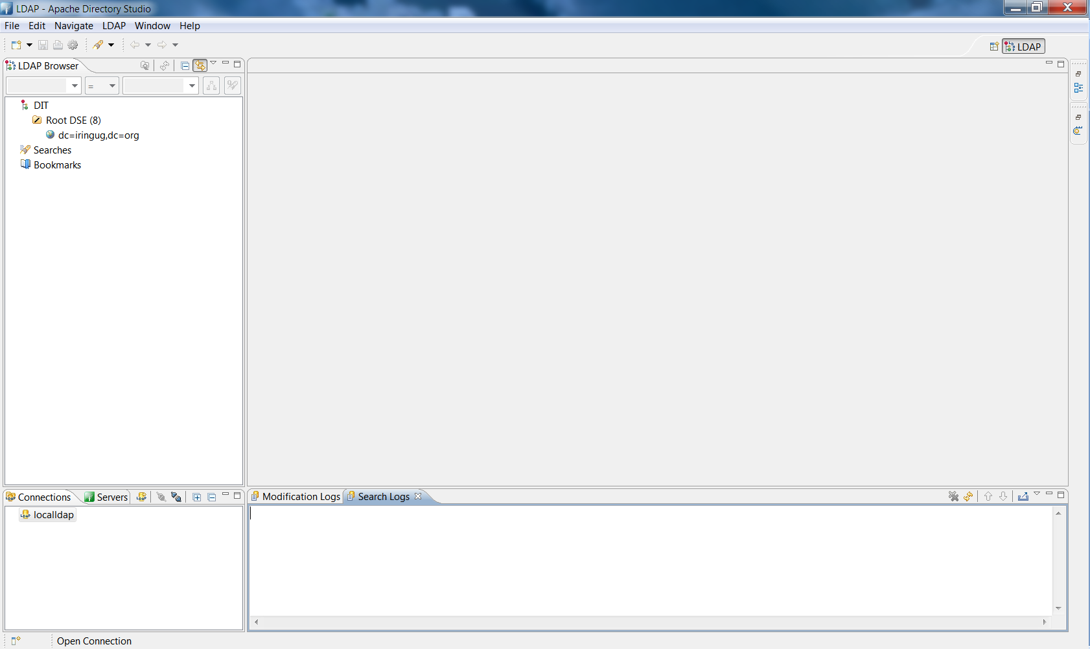

- Right click the entry “dc=iringug,dc=org” and click “Import”, “LDIF Import”.
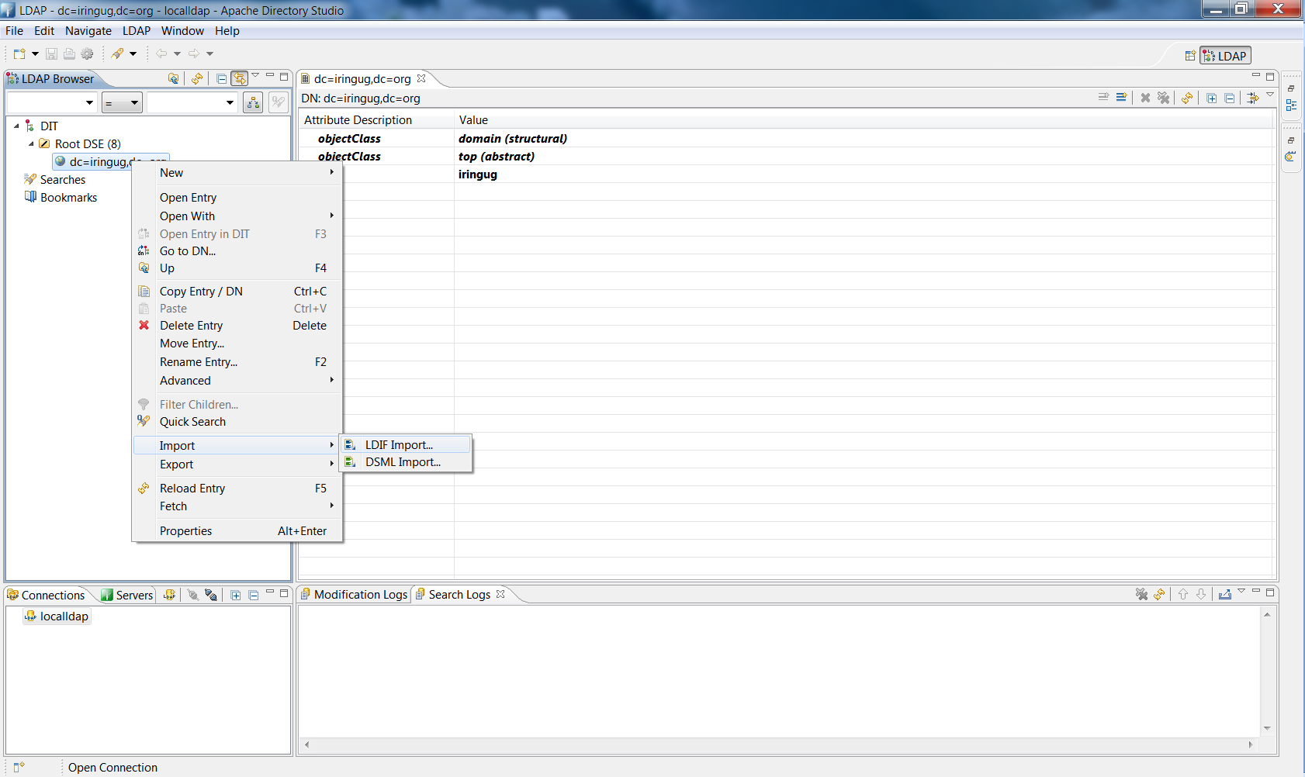
- Click “Browse” and open the file “default.ldif” from a directory, e.g., “C:\iring-tools\trunk\LDAP” and check the box before “Overwrite existing logfile”. Then click “Finish”.
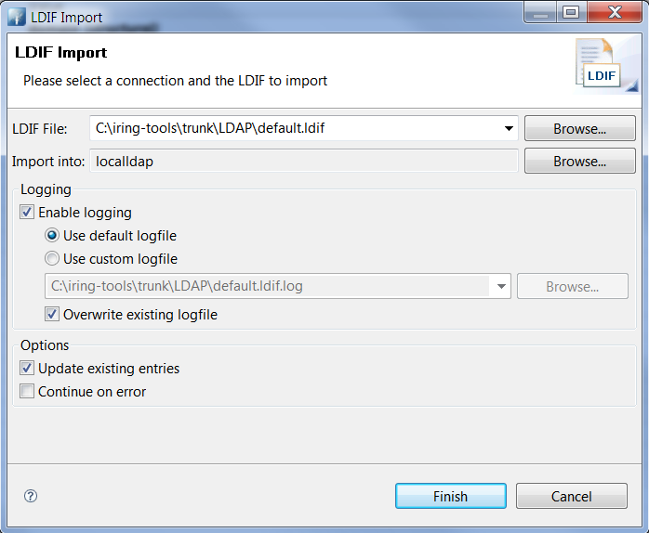
- Double click the entry “dc=iringug,dc=org” to see the imported directory.

